

Sample Entry
Dan Mills Chapter Program Award

Region:

Chapter:

Name of Nominee:

Table of Contents
- Transmittal Letter
- CTTC RVC Letter of Recommendation
- Narrative Section
- Point Tally Form
- PAOE CTTC Category Sheet
- Any Additional Information

Transmittal Letter

The transmittal letter is written by the nominator and provides a brief overview of the nominee’s qualifications. The nominator is typically a chapter representative or the CTTC RVC.

Example Transmittal Letter:

Dear Chapter Technology Transfer Committee,

I am pleased to nominate <Name> for CTTC’s Dan Mills Chapter Programs Award. <Name> served as the <Society Year> CTTC Chapter Chair for the <Chapter> and they went above and beyond to promote chapter programs to our local ASHRAE members.

Include an overview of accomplishments, such as programs, activities, meetings or other events that the nominee worked on during their tenure as CTTC Chapter Chair. Be sure to mention any extraordinary efforts or unique successes.

Best Regards,
<Name of Nominator>

CTTC RVC Letter of Recommendation

The CTTC RVC Letter of Recommendation is similar to the Transmittal Letter and may follow the same template. The CTTC RVC Letter of Recommendation is not needed if the CTTC RVC is serving as the nominator and already wrote the Transmittal Letter.

Narrative Section

The Narrative Section provides a more detailed overview of how the nominee succeeded as CTTC Chapter Chair. Highlight specific areas where the nominee excelled and give examples.

Example Narrative Section:

<Name of Nominee>, <Chapter>, <Region>

Years of CTTC service:
- CTTC Chapter Member:
- CTTC Chapter Chair:

- Planning for Successful Chapter Programs
How did the nominee plan out their successful year? How often did they communicate with their CTTC RVC? Who did they work with in the chapter to plan and promote the programs?
- Increasing Attendance at Chapter Meetings
How did the nominee cater programs to the interests of chapter members? Provide any stats on how much attendance increased. How were programs offered to accommodate more attendees?
- Successful Programs
Was there a program or two that were particularly successful? What made them successful and what role did the nominee play in their success?
- Promoting Special Chapter Programs
Did the nominee oversee the development of any out of the ordinary programs? Did they do joint meetings or work with a new organization? Did they collaborate with other chapters? Were there specific topics that were highlighted over the year, such as refrigeration?
- PAOE
How did the nominee highlight PAOE throughout the year?

Point Tally Form

Completed Point Tally Form, which is available on the CTTC webpage and shown below.

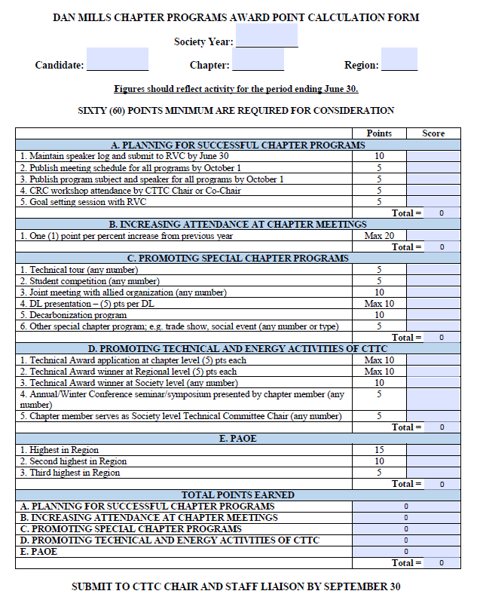

PAOE CTTC Category Sheet

Include a copy of the previous Society Year’s PAOE CTTC category sheet. This shows where the nominee’s chapter placed in relation to other chapters within the same Region. The CTTC RVC has access to this PAOE report.

You may also include the CTTC category sheet breakdown for the nominee’s chapter, which shows how many points were earned for each category (but this is optional).

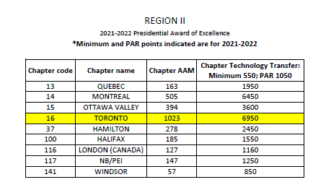

Any Additional Information

You may include any additional information to help support your nomination. This could include program marketing (such as flyers or social media posts), PointPoint slides, an overview of the chapter’s program schedule, program photos, etc. This is a great place to add information that couldn’t be summarized in words under the Narrative Section.

