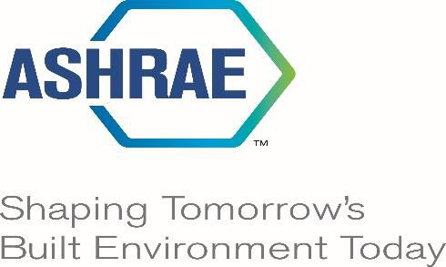

Advancing the Arts and Sciences of HVAC&R
for the Benefit of Humanity

MULTI DISCIPLINARY TASK GROUPS
(MTG) REFERENCE MANUAL

MULTI DISCIPLINARY TASK GROUPS
(MTGs)

062522 Initial release
011124 Revision

Table of Contents
Foreword 3
Purpose 3
Formation 3
Authority Documents 4
Authority Documents as they apply to the MTG 4
Certificate of Consolidation 4
ASHRAE By-Laws 4
ASHRAE Code of Ethics 4
ASHRAE Discrimination and Harassment Policy 5
Rules of the Board 5
Technical Activities Committee (TAC) Manual of Procedures (MOP) 5
Organizational Chart 5
Participants 6
Proposal 6
Product 6
MTG Expectations 6

Foreword
ASHRAE Multidisciplinary Task Groups (MTGs) is a group that reports to the Technical Activities Committee (TAC) and responsive to:
- the purposes of ASHRAE as described in the Certificate of Consolidation,
- compliant to the Society Bylaws,
- guided by the Rules of the Board, and
- abiding with the Commercialism Policy, the Code of Ethics, and the Harassment Policy.

Initiated during Lynn Bellenger’s service as Society President, the MTGs are structured to respond to specific problems and tasks with a need for expertise from differing disciplines. By nature, these are directed more to unanticipated topics, relatively short-term tasks requiring creativity and problem-solving skills, as well as technical expertise in differing areas.

Purpose
The overall purpose of MTG is the advancement of the Arts and Sciences in response to Society emerging needs, multidisciplinary in nature, and encompassing the expertise of two or more FGs. This could include, but not limited to, Position Documents, press releases, and white papers.

Formation
An MTG is formed when the Society, or an individual member, has determined a need for a specific activity in a field of interest. It encompasses the expertise of two or more FGs, project committees (e.g., SPCs, SSPCs, GPCs), standing committees, or committees and groups outside of ASHRAE.

MTGs, in order to be effective in addressing emerging needs, must be responsive to the defined need, transparent, inclusive and representative of the participating stakeholders, and be accountable in meeting scope and timeline to the Technical Activities Committee (TAC). The MTGs must conduct their task with a clear, unified vision and constructive consensus towards definition of strategies in response to the emerging need(s).

Authority Documents

Authority Documents as they apply to the MTG

Commentary:
The Authority Documents have been placed in the front of this Reference Manual, versus in an Appendix, so that a casual reader will be exposed these most important documents.

Certificate of Consolidation

Commentary: On January 16, 1959, the American Society of Heating and Air-Conditioning
Engineers, Inc. and The American Society of Refrigeration Engineers merged. The
purpose of the consolidated corporation was stated in ten (10) guidelines (Certificate Of Consolidation | ashrae.org). Only the first tenant is presented for brevity.

(a) To advance the arts and sciences of heating, refrigeration, and air conditioning and ventilation, and the allied arts and sciences, for the benefit of the general public.

ASHRAE By-Laws - ASHRAE Bylaws - June 2022

Commentary:
Section 7.8: Technical Activities Committee. This standing committee, the members of which are elected individually by the Board of Directors, shall plan for and have charge of the activities of the technical committees, task groups, and technical resource groups appointed to further the advancement of the arts and sciences of heating, refrigerating, air conditioning, ventilating, and the allied arts and sciences for the public benefit. Subject to the procedures prescribed by the Board of Directors, the Technical Activities Committee shall approve the formation of technical committees, task groups and technical resource groups as necessary to carry out the objectives of the committee. The committee shall also determine the scope of activities of each of these technical committees, task groups and technical resource groups.

ASHRAE Code of Ethics (www.ashrae.org/about/governance/code-of-ethics)

Commentary: This is stated in the Rules of the Board (ROB) section 1.140 CODE OF
ETHICS
This is a unique attribute for an organization that does not require paid member to participate or any professional accreditation such as a Professional Engineers License. There are eight (8) requirements to follow, however, for the purpose of the TC MOP item E states: “We shall avoid real or perceived conflicts of interest whenever possible, and disclose them to affected parties when they do exist.”

ASHRAE Discrimination and Harassment Policy (www.ashrae.org/about/governance/ashrae-discrimination-and-harassment-policy)

Rules of the Board (www.ashrae.org/about/governance/rules-of-the-board)

Commentary: 2.428.004 STRATEGIC PLAN: This committee [TAC is responsible for assisting in the development of the Strategic Plan with the input of all the MTGs] shall develop procedures for recommending updates to the strategic plan on a continuous basis. As a minimum the committee shall submit a repost to the council prior to the Annual Meeting. The report includes the current status of each activity which support the fulfillment of the committee’s assignments under the strategic plan. The committee shall report to the council all recommendations for changes to the strategic plan as provided by the committee’s constituents prior to the Annual Meeting.

Technical Activities Committee (TAC) Manual of Procedures (MOP)
(www.ashrae.org/tac)

Organizational Chart

Commentary: Here is where you fit into the ASHRAE organizational structure reporting to the Technical Activities Committee (TAC) through your Section Head.

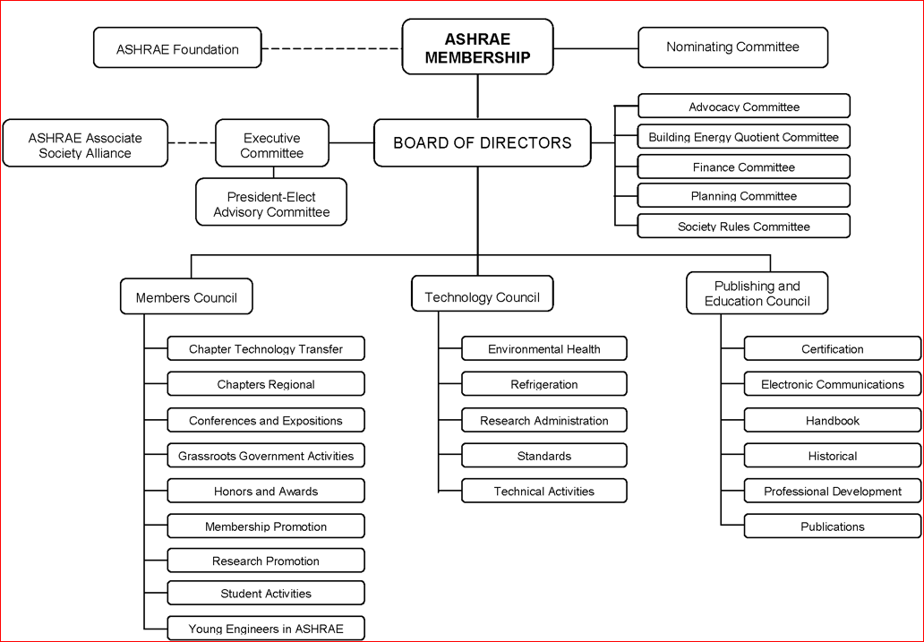

Participants
All involved in the process should be ASHRAE members embracing the following:
- Representative experts in a specific discipline related to the task,
- Creative problem solvers,
- Comfortable in breaking paradigms,
- Visionary, and
- Open to constructive dialog and consideration of alternative solutions and strategies.

There should be at least two cognizant Functional Groups (FGs) groups appointing not more than two members each to the MTG. The MTG’s leadership shall be appointed by the MTG Section Head. The leadership team should include expertise in problem solving, and their terms should continue until a final report is submitted. The leadership team should be empowered to add further participants with the consent of the Section Head.

Proposal
- A request for consideration of the formalizing of a MTG can be submitted by any member or entity of ASHRAE including, but not limited to, the Board of Directors or its Executive Committee, a Council, the College of Fellows, Chapters, Standing Committees, and individual ASHRAE Members.
- Proposal is to address an emerging problem which relates to the advancement of the arts and sciences of HVAC&R for the benefit of humanity and the current ASHRAE Strategic Plan.
- The proposal, to be submitted to TAC, should include content on the following:
- Title, purpose, and scope;
- Name and e-mail address of the proposer,
- Clear problem statement with desired deliverable(s),
- Background of scope or problem statement,
- Anticipated timeline and suggested sunset date,
- List of cognizant ASHRAE and non-ASHRAE committees and groups,
- Reference and names of eligible participants, and
- Entities not associated with ASHRAE but are interested in the problem.

- TACs approval will consider the proposed MTG to meet a notable needs in the industry or the current ASHRAE Strategic Plan, deliverables, and proposed timeline. TAC may choose to revise the MTG proposal as needed.

Product
- The deliverable will minimally be a final report, clearly recommending steps to be considered by ASHRAE in the advancement of the Arts and Sciences of HVAC&R in response to the identified emerging society need.
- Additional deliverables will be determined by the nature of the scope or problem statement.
- The final report will be presented to TAC for review and approval.
- Once approved, the report may be presented to Technology Council, the Board of Directors, and other ASHRAE and non-ASHRAE groups, where endorsements may be received.

MTG Expectations

Commentary:
To empower the MTG to be as flexible and responsive to their defined task(s) as possible the Technical Activities Committee has decided to provide a list of “expectations” [in some instances this is noted as “shall”] rather than a list of requirements generally found in a Manual of Procedures (MOP).

- The formation of a new MTG requires a Title, Purpose, and Scope (TPS), identification of deliverables, and a timeline for presenting the final work product to TAC for review and approval.
- Will sunset upon completion of final report in accordance with the proposed timeline.
- The leadership team:
  - Shall have completed the ASHRAE Leadership Development Auto-Tutorials (Technical Activities Committee (ashrae.org)).
  - Together with the Section Head shall be fully empowered. The Chair should be not a captain, timekeeper, or parliamentarian, but an enabler for creative outcomes and a visionary in inspiring others.
  - Should focus on ideation for alternatives and converging consensus (refer Block B.1.d of the Leadership Development Auto-Tutorial).
- It is recommended MTGs meet virtually a minimum of 6 times per year with suggested 50-minute meetings. No requirement for in-person meetings.
- No reimbursement for travel expenses.
- Membership
  - Leadership positions shall include a Chair and Vice Chair. Optional positions may include Secretary, Webmaster, and Membership Coordinator.
  - Chair and Vice Chair will serve until the final product of the MTG is approved.
  - It is strongly encouraged that the MTG has no less than seven and not more than twenty voting members.
  - Leadership positions and Voting Members must be ASHRAE members in good standing. This may be waived with the approval of the Section Head.
  - Voting membership balance shall be considered by TAC when approving MTG membership.
  - The Chair and Vice Chair will be responsible to ensure individual bias is avoided.
  - Provisional corresponding membership will be available at the discretion of the Chair.
  - MTG members shall adhere to ASHRAE Code of Ethics, ASHRAE Discrimination and Harassment Policy and other ASHRAE policies that may apply.
- Chair may choose to follow any strategies to reach consensus. Limited use of Simplified Roberts Rules of Order should be used to maintain meeting organization and agenda.
- Do not present motions unless consensus is reached on a final decision, report, or deliverable.
- Reporting
  - Provide a written quarterly update to the Section Head including initiatives for maintaining balance of voting members and avoiding individual bias.
  - Post DRAFT meeting agenda at least 15 days before meeting.
  - Post DRAFT meeting minutes no later than 15 days after a meeting (Chair may choose to list outcomes reached through consensus in lieu of detailed minutes).
  - Post an ongoing list of action items accomplished on Basecamp and webpage (no need for detailed meeting minutes).
  - All meetings must include advanced notice using all available ASHRAE resources. Maintain a MTG website and basecamp.
- All members of the MTG will be advised at the start of any meeting that the Code of Ethics will be followed and a link to the ASHRAE website provided.
- All meetings are open to whomever chooses to attend.
- Provide time for Open Forum (comments from visitors and guests) at the end of each meeting.

